Civil war in Georgia

UNSC Resolution: | 971
Date of adoption: | 12-Jan-1995
Operative paragraph: | 4
Demand number: | 971.04.11

David Siroky

Wording of demand
reach substantive progress in negotiations aimed at achieving a comprehensive political settlement of the conflict, including on the political status of Abkhazia, respecting fully the sovereignty and territorial integrity of the Republic of Georgia, under the auspices of the UN and with the assistance of the Russian Federation as facilitator and with participation of representatives of the OSCE

List of addressees of the demand
Government of Georgia, Abkhazia

Short-term compliance

Description of the addressee(s)’ conduct

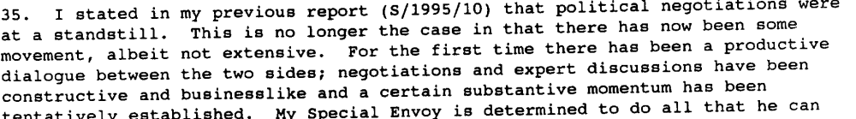s/1995/181

- 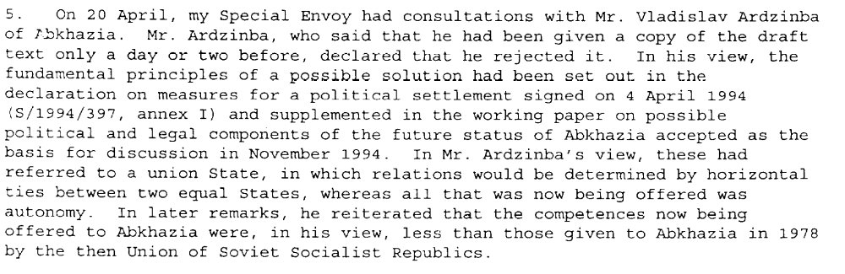s/1995/342

- 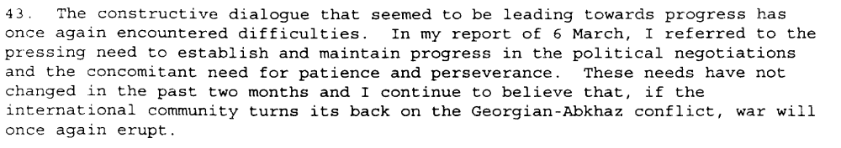s/1995/342

Assessment

Short-term compliance
No or marginal compliance (1) | Medium low compliance (2) | Medium high compliance (3) | Full or almost full compliance (4)

Considerations underlying the assessment

Medium-term compliance

Description of the addressee(s)’ conduct

s/1995/181

- s/1995/342

- s/1995/342
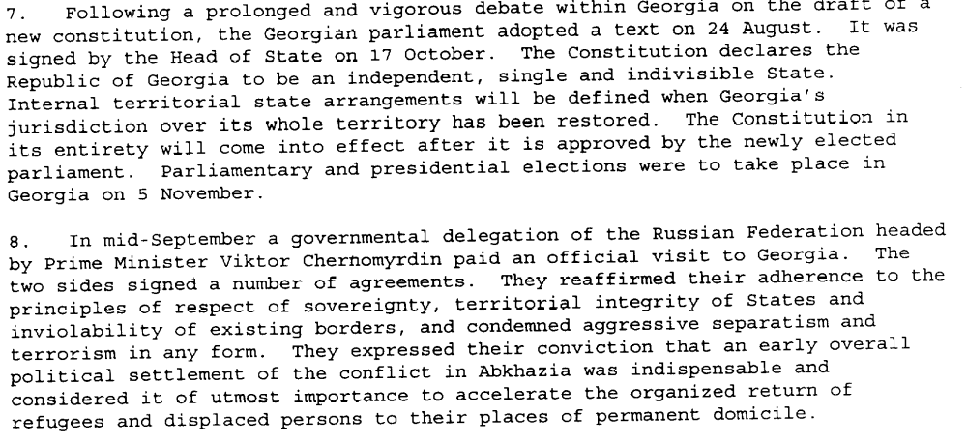S/1995/937

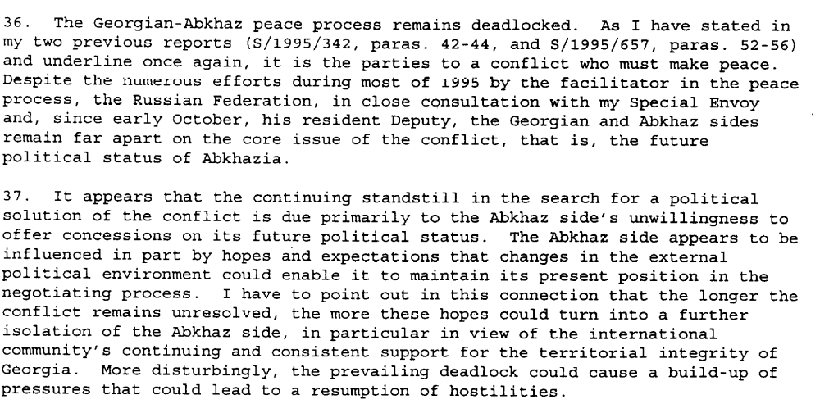S/1995/937

Assessment

Medium-term compliance
No or marginal compliance (1) | Medium low compliance (2) | Medium high compliance (3) | Full or almost full compliance (4)

Considerations underlying the assessment

Depth of demand

Assessment

Level of depth of demand
Low depth of demand (1) | Medium depth of demand (2) | High depth of demand (3)

Considerations underlying the assessment

Level of confidence about coding decisions
Level of confidence about coding decision
Extremely high | High | Moderate

Comments to IPI (if any)

Civil war in Georgia

UNSC Resolution: | 971
Date of adoption: | 12-Jan-1995
Operative paragraph: | 5
Demand number: | 971.05.11

David Siroky

Wording of demand
comply with commitments with regard to the return of refugees and displaced persons, as undertaken in the Quadripartite Agreement (Abkhaz side in particular called upon to accelerate the process significantly)

List of addressees of the demand

Government of Georgia, Abkhazia

Short-term compliance

Description of the addressee(s)’ conduct

The very slow pace of return of refugees to Abkhazia dominated the agenda. The Abkhaz refused to sign a declaratuon that would have allowed for a speedier return and in larger numbers. It did, however, reduce the review period for consideration of applications from four to two weeks (S/1995/10, p. 1, par. 3)

“..the volume of movement has been very disappointing....since the end of Nov, however, formal repatriation has virtually halted.” (S/1995/10, par. 8 and par. 10)”

“Despite isolated incidents, the Abkhaz have made efforts to ensure the security of returnees...sustained efforts are required to create a secure climate conducive to repatriation (S/1995/10, par. 11 and par. 39)”

Assessment

Short-term compliance
No or marginal compliance (1) | Medium low compliance (2) | Medium high compliance (3) | Full or almost full compliance (4)

Considerations underlying the assessment

Medium-term compliance

Description of the addressee(s)’ conduct

The very slow pace of return of refugees to Abkhazia dominated the agenda. The Abkhaz refused to sign a declaratuon that would have allowed for a speedier return and in larger numbers. It did, however, reduce the review period for consideration of applications from four to two weeks (S/1995/10, p. 1, par. 3)

“..the volume of movement has been very disappointing....since the end of Nov, however, formal repatriation has virtually halted.” (S/1995/10, par. 8 and par. 10)”

“Despite isolated incidents, the Abkhaz have made efforts to ensure the security of returnees...sustained efforts are required to create a secure climate conducive to repatriation (S/1995/10, par. 11 and par. 39)”

“Since my previous report to the SC, there has been no major change in the situation of displaced persons...(S/1995/657, par. 10)”

“The Abkhaz side maintained its previous position of allowing only 200 persons per week to return. This continues to be unacceptable to the other parties (S/1995/657, par. 12)”

“There has been no significant change in the situation of the displaced persons (S/1995/937, par. 10)”

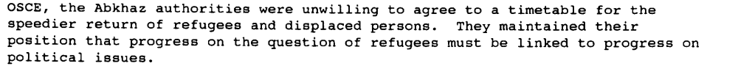s/1995/181

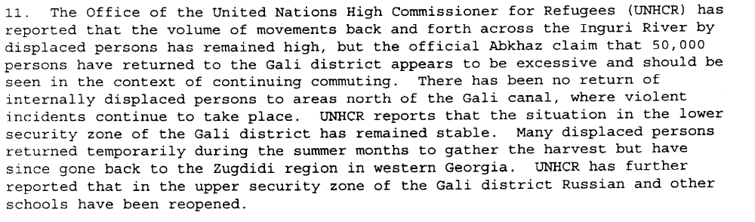S/1995/937

Assessment

Medium-term compliance
No or marginal compliance (1) | Medium low compliance (2) | Medium high compliance (3) | Full or almost full compliance (4)

Considerations underlying the assessment

Depth of demand

Assessment

Level of depth of demand
Low depth of demand (1) | Medium depth of demand (2) | High depth of demand (3)

Considerations underlying the assessment

Level of confidence about coding decisions

Level of confidence about coding decision
Extremely high | High | Moderate

Comments to IPI (if any)

